**Lab cycle 2**

1. Write a PL/SQL code to accept the text and reverse the given text. Check the text is palindrome or not

Code:

DECLARE

    s VARCHAR2(10) := 'malayalam';

    l VARCHAR2(20);

    t VARCHAR2(10);

BEGIN

    FOR i IN REVERSE 1..Length(s) LOOP

        l := Substr(s, i, 1);

        t := t ||''||l;

    END LOOP;

    IF t = s THEN

      dbms_output.Put_line(t ||''||' is palindrome');

    ELSE

      dbms_output.Put_line(t ||''||' is not palindrome');

    END IF;

END;

 Output:

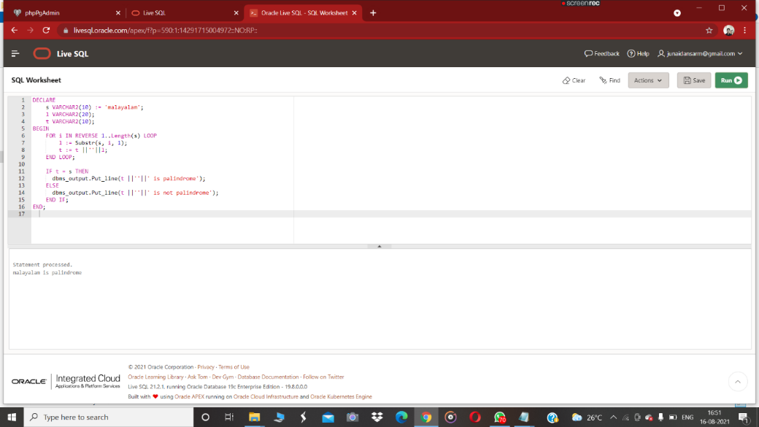

Q2. Wite a program to read two numbers; If the first no > 2nd no, then swap the numbers; if the first number is an odd number, then find its cube; if first no < 2nd no then raise it to its power; if both the numbers are equal, then find its sqrt.

Code:

DECLARE

   a INTEGER :=5;

   b INTEGER :=4;

   temp INTEGER:=0;

   c INTEGER;

   d INTEGER :=2;

   cube INTEGER;

BEGIN

    IF a > b THEN

      temp :=a;

      a :=b;

      b := temp;

      DBMS_OUTPUT.PUT_LINE('After the swapping the a value is '||a ||' and b value is  '||b);

      IF  MOD(b,d) !=0 THEN

        cube :=a* a * a;

        DBMS_OUTPUT.PUT_LINE('cube of a is:'||cube);

      ELSE

        DBMS_OUTPUT.PUT_LINE('The first number is even:');

      END IF;

   ELSIF a < b THEN

      c :=a **b;

      DBMS_OUTPUT.PUT_LINE('power is:'||c);

  ELSIF a =b THEN

     DBMS_OUTPUT.PUT_LINE('sqare root of a is:'||(SQRT(a)));

     DBMS_OUTPUT.PUT_LINE('sqare root of b is:'||(SQRT(b)));

  END IF;

END;

**Output:**

Statement processed.  
After the swapping the a value is 4 and b value is 5  
cube of a is:64

1. Write a program to generate first 10 terms of the Fibonacci series.

Code:

DECLARE

   t1 NUMBER :=0;

   t2 NUMBER :=1;

   t3 NUMBER ;

BEGIN

   dbms_output.put_line(t1);

   dbms_output.put_line(t2);

   for i in 3 ..10 loop

   t3 :=t1 + t2;

   dbms_output.put_line(t3);

   t1 := t2;

   t2 := t3;

   END LOOP;

END;

Output:

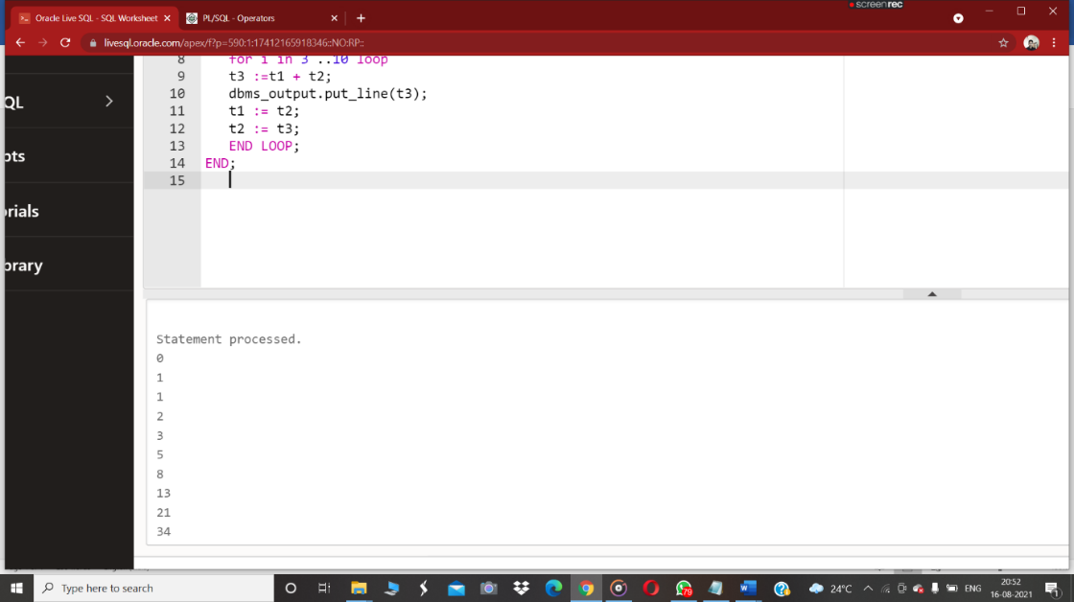

Q4. Write a PL/SQL program to find the salary of an employee in the EMP table (Get the empno from the user). Find the employee drawing minimum salary. If the minimum salary is less than 7500, then give an increment of 15%. Also create an emp %rowtype record. Accept the empno from the user, and display all the information about the employee.

**PL/SQL CODE:**

create table EMP(emp_no int primary key,emp_name varchar(20),salary int);

insert into EMP values(101,'arun',50000);

insert into EMP values(102,'arun',6500);

insert into EMP values(103,'arun',7500);

DECLARE

   emp1 EMP%rowtype;

   sal EMP.salary%type;

BEGIN

   SELECT salary INTO sal FROM EMP WHERE emp_no = 102;

   IF sal <= 7500 THEN

     UPDATE EMP SET salary = salary+salary* 15/100 WHERE emp_no = 102;

   ELSE

     DBMS_OUTPUT.PUT_LINE ('NO INCREMENT');

   END IF;

   SELECT * into emp1 FROM EMP WHERE emp_no = 102;

   DBMS_OUTPUT.PUT_LINE ('Name: '||emp1.emp_name);

   DBMS_OUTPUT.PUT_LINE ('employee number: '||emp1.emp_no);

   DBMS_OUTPUT.PUT_LINE ('salary: '|| emp1.salary);

END;

**OUTPUT:**

Statement processed.  
Name: arun  
employee number: 102  
salary: 8596

Q5. Write a PL/SQL **function** to find the total strength of students present in different classes of the MCA department using the table Class(ClassId, ClassName, Strength);

**Table creation And insertion**

create table class(cls_id varchar(20),cls_name varchar(20),Strength int);

insert into class values('MCA21','S2A',59);

insert into class values('MCA21','S2B',58);

insert into class values('MCA20','S5A',40);

insert into class values('MCA20','S5B',34);

**function code:**

CREATE OR REPLACE FUNCTION findTotalStrength

   RETURN NUMBER IS

   s_count NUMBER(20):=0;

   BEGIN

      SELECT sum(strength) INTO s_count FROM class;

   RETURN (s_count);

   END;

**Function Output:**

     Function created.

**Function call**

DECLARE

  c NUMBER(5):=0;

BEGIN

  C:= findTotalStrength();

  DBMS_OUTPUT.PUT_LINE('Totel students in mca department is:'||c);

END;

**Output:**

Statement processed.

Totel students in mca department is:191

1. Write a PL/SQL **procedure** to increase the salary for the specified employee. Using empno in the employee table based on the following criteria: increase the salary by 5% for clerks, 7% for salesman, 10% for analyst and 20 % for manager. Activate using PL/SQL block.

**procedure code**

CREATE OR REPLACE PROCEDURE increSalary

IS

emp1 emp%rowtype;

sal emp.salary%type;

dpt emp.emp_dpt%type;

BEGIN

SELECT salary,emp_dpt INTO sal,dpt FROM emp WHERE emp_no = 104;

   IF dpt ='clerk' THEN

     UPDATE emp SET salary = salary+salary* 5/100 ;

   ELSIF dpt = 'salesman' THEN

     UPDATE emp SET salary = salary+salary* 7/100  ;

   ELSIF dpt = 'analyst' THEN

     UPDATE emp SET salary = salary+salary* 10/100  ;

  ELSIF dpt = 'manager' THEN

     UPDATE emp SET salary = salary+salary* 20/100  ;

  ELSE

     DBMS_OUTPUT.PUT_LINE ('NO INCREMENT');

   END IF;

   SELECT * into emp1 FROM emp WHERE emp_no = 104;

   DBMS_OUTPUT.PUT_LINE ('Name: '||emp1.emp_name);

   DBMS_OUTPUT.PUT_LINE ('employee number: '||emp1.emp_no);

   DBMS_OUTPUT.PUT_LINE ('salary: '|| emp1.salary);

   DBMS_OUTPUT.PUT_LINE ('department: '|| emp1.emp_dpt);

END;

**table creation**

create table emp(emp_no int,emp_name varchar(20),salary int,emp_dpt varchar(20));

insert into emp values(101,'arun',50000,'salesman');

insert into emp values(102,'appu',6500,'manager');

insert into emp values(103,'ammu',7500,'clerk');

insert into emp values(104,'anitha',7500,'analyst');

**calling function**

DECLARE

BEGIN

  increSalary();

END;

**Output:**

Statement processed.  
Name: anitha  
employee number: 104  
salary: 8250  
department: analyst

1. Create a **cursor** to modify the salary of ‘president’ belonging to all departments by 50%

**Table creation and insertion command:**

create table emp(emp_no int,emp_name varchar(20),salary int,emp_dpt varchar(20),dsgt varchar(20));

insert into emp values(101,'arun',50000,'sales','president');

insert into emp values(102,'appu',6500,'Ac','president');

insert into emp values(103,'ammu',7500,'HR','manager');

insert into emp values(104,'anitha',7500,'Ac','snr grade');

insert into emp values(105,'anitha.c',7500,'HR','president');

**Cursor code:**

DECLARE

    total_rows number(2);

    emp1 EMP%rowtype;

BEGIN

 UPDATE emp SET salary = salary + salary * 50/100 where dsgt = 'president';

 IF sql%notfound THEN

     dbms_output.put_line('no employee salary updated');

 ELSIF sql%found THEN

    total_rows := sql%rowcount;

    dbms_output.put_line( total_rows || ' employee salary details  updated');

 end if;

end;

**output:**

Statementprocessed.  
3 employee salary details updated

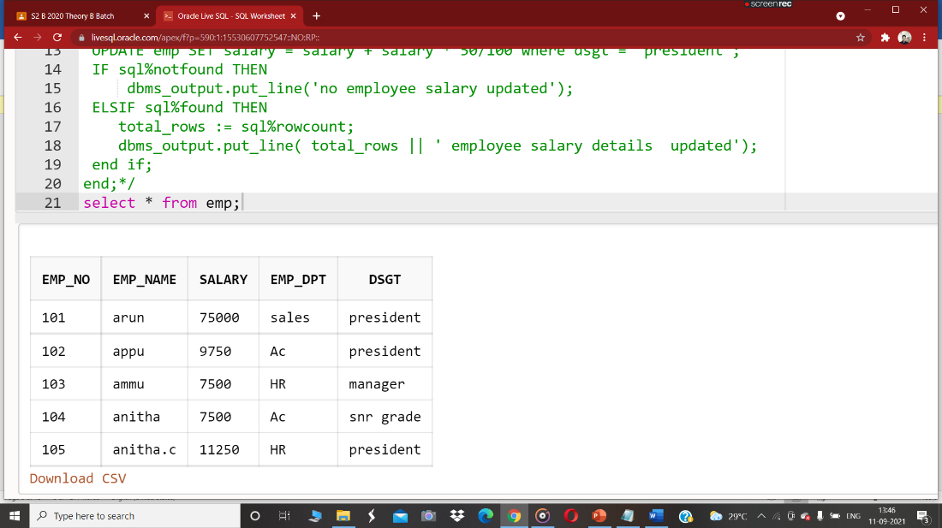

1. Write a **cursor** to display list of Male and Female employees whose name starts with S.

**Table creation and insert command:**

create table emp(emp_no varchar(20),emp_name varchar(20),salary int,emp_dpt varchar(20),gender varchar(10));

insert into emp values('101','arun',50000,'sales','male');

insert into emp values('102','sandeep',6500,'Ac','male');

insert into emp values('103','ammu',7500,'HR','female');

insert into emp values('104','snitha',7500,'Ac','female');

insert into emp values('105','anitha.c',7500,'HR','female');

**Cursor code:**

DECLARE

 CURSOR emp1 is SELECT * FROM emp WHERE emp_name like ('s%');

 emp2 emp1%rowtype;

BEGIN

 open emp1;

 loop

  fetch emp1 into emp2;

  exit when emp1%notfound;

  dbms_output.put_line('employee information: '||' '||emp2.emp_no || ' ' || emp2.emp_name || ' ' || emp2.salary|| ' '||emp2.emp_dpt||' '||emp2.gender);

 end loop;

 dbms_output.put_line('Totel number of rows :'||emp1%rowcount);

close emp1;

end;

**output:**

Statement processed.  
employee information: 102 sandeep 6500 Ac male  
employee information: 104 snitha 7500 Ac female  
Totel number of rows :2

1. Create the following tables for Library Information System: Book : (accession-no, title, publisher, publishedDate, author, status). Status could be issued, present in the library, sent for binding, and cannot be issued. Write a **trigger** which sets the status of a book to "cannot be issued", if it is published 15 years back.

**Table creation:**

create table book(accession_no int , title varchar(20), publisher varchar(20), publishedDate date, author varchar(20), status varchar(30));

**Trigger code:**

CREATE OR REPLACE TRIGGER search1

 before insert  ON book

 FOR EACH ROW

 declare

  temp date;

BEGIN

 select sysdate into temp from dual;

 if inserting  then

  if :new.publishedDate < add_months(temp, -180) then

       :new.status:='cannot be issued' ;

  end if;

 end if;

end;

**inserting command:**

insert into book values( 2511,'abcd','cp','21-jan-2009','john','issued');

insert into book values( 2512,'efhj','cp','30-mar-2010','malik','present in the library');

insert into book values( 2513,'hijk','cp','21-june-2011','sonu','sent for binding');

insert into book values( 2514,'lmno','cp','01-sep-2016','johns','issued');

insert into book values( 2515,'pqrst','cp','21-jan-2004','joppy','can not be issued');

insert into book values( 2516,'uvwx','cp','21-jan-2006','juosoop',' issued');

SELECT * FROM book;

**Output:**

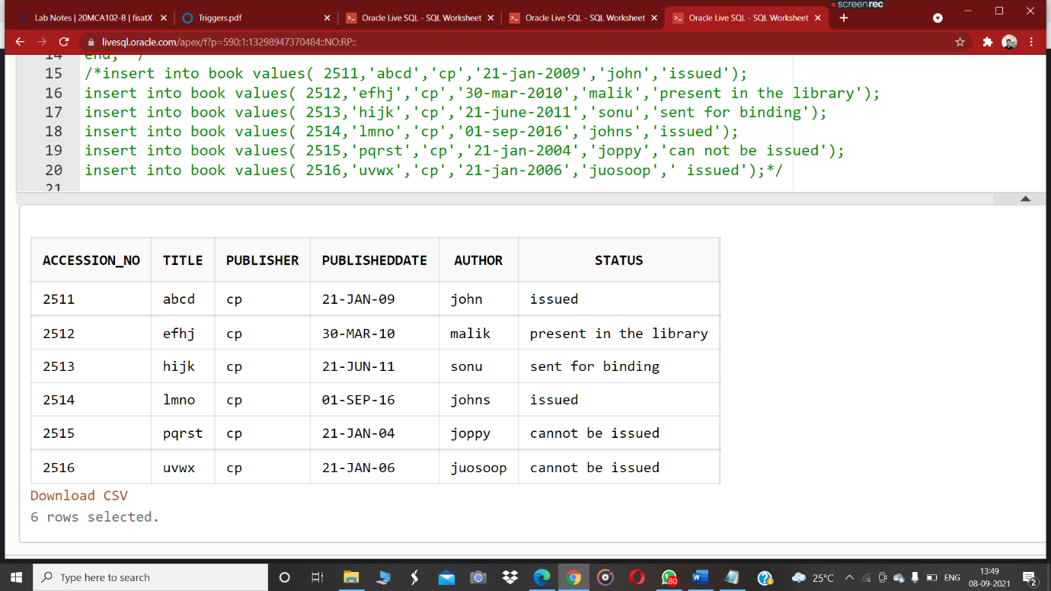

1. Create a table Inventory with fields pdtid, pdtname, qty and reorder_level. Create a **trigger** control on the table for checking whether qty<reorder_level while inserting values.

**Code:**

  create table inventory(pdtid number primary key, pdtname varchar(10), qty int,reorder_level number);

CREATE OR REPLACE TRIGGER checking

 before insert  ON inventory

 FOR EACH ROW

declare

BEGIN

 if inserting  then

  if :new.qty > :new.reorder_level then

       :new.reorder_level:=0;

  end if;

 end if;

end;

insert into inventory values(101,'pencil',100,150);

insert into inventory values(112,'tap',50,100);

insert into inventory values(121,'marker',200,150);

insert into inventory values(151,'notbook',500,250);

select * from inventory;

**Output:**

